Activity
Learning Objective: Creating a Character Profile 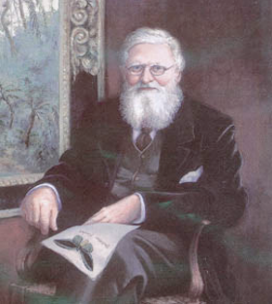
This is: …………………………………………
His work : ………………………………………
He is wearing ….…………………………………………………… ………………………………………………………………………. ………………………………………………….….…………………
He has …………………………………………hair. He has a …………………………………………… beard.
He likes …….…………………………………………..…………. ……………………………………………………………………… ……………………………………………………………………… ………………………………………………………………………

Draw a picture of Alfred Russel Wallace and describe him

